Table of Contents
1. Rationale
1.1 Problem Description
1.2 Background
1.3 Community Impact
1.4 Proposed Solution
1.5 Computational Thinking
1.6 Algorithm Design
1.7 SDG Alignment
1.8 Open Source
1.9 Digital Public Goods
2.Algorithm
3.Pseudocode
4.Flowcharts
5.Functional Modules
6.Expected Outputs
7.GitHub Evidence
8.References

1.Rationale
1.2 Problem Description
Many primary and secondary schools in Sierra Leone still record attendance and test scores in paper registers and exercise books. Teachers must add up marks and count absences by hand at the end of each term. This is slow and error-prone, and registers can be lost, damaged or altered. As a result, students who are frequently absent or performing poorly are often noticed too late, when the term is already over and little can be done to help them. The problem to be solved is therefore: schools lack a simple, reliable and low-cost way to record student attendance and scores, and to flag students who are at risk early.
1.3 Background
Sierra Leone has expanded access to schooling in recent years, including the Free Quality School Education programme, and school enrolment has grown. Larger classes, however, mean more records for each teacher to manage. Many schools, especially in rural districts, have unreliable electricity and limited internet access, and few have dedicated administrative staff. Head teachers and district education officers therefore struggle to get accurate, up-to-date information on attendance and performance. The problem exists mainly because of manual processes, large class sizes, limited resources and the absence of simple tools designed for low-connectivity environments.
Who Is Affected
Students, who may drop behind or out without anyone noticing.
Teachers, who spend hours on manual calculation and record keeping.
Parents and guardians, who receive little timely information about their child's progress.
Head teachers and district education officers, who need reliable data for planning and decisions.
1.4 Community Impact
School track SL is expected to reduce teacher workload, improve the accuracy of records, and allow early identification of at-risk students so schools can act (for example, by contacting a guardian) before a term ends. Beneficiaries are students, teachers, parents, school management and education authorities. Long-term sustainability comes from keeping the design simple, working offline-first, using opensource tools that cost nothing to license, and encouraging local ICT students and developers to maintain and extend the system.
1.5 Proposed Solution
School track SL is a modular system that allows a teacher to (1) register students, (2) record daily attendance, (3) record assessment scores, (4) automatically calculate attendance percentage, average score and grade, (5) flag students who are at risk, and (6) generate a class report. The system is designed to work offline and to synchronize data when a connection is available.
1.6 Computational Thinking Process
Decomposition: The large problem is broken into smaller parts: student registration, attendance, scores, calculations, risk checking, reporting and data synchronization.
Pattern recognition: Every class and every term follow the same pattern: record data for each student, calculate the same measures, and apply the same rules.
Abstraction: The design focuses on the essential data (student ID, name, class, attendance, scores) and ignores unnecessary detail such as the school's building or timetable.
Algorithm design: Each part is expressed as clear, ordered steps that can be followed by any developer, using decisions and loops.
Algorithm Design (Summary)
The algorithm displays a menu and repeats until the user chooses to exit. Depending on the choice, it calls a module. Each module validates its input, processes it using decision and repetition structures, and produces an output.
1.7 SDG Alignment
SDG 4: Quality Education. Early identification of struggling students supports inclusive and equitable quality education and helps keep children in school.
SDG 10: Reduced Inequalities. An offline-first design supports schools in rural and low-connectivity areas that are often left behind.
SDG 17: Partnerships for the Goals. Open collaboration among schools, universities and developers supports shared solutions.
1.8 Open-Source Justification
The system should be open source because schools and government have limited budgets and cannot afford expensive licenses. Open-source software is free to use, can be adapted to local needs (for example, the local grading scale or language), and can be inspected by anyone, which builds trust in how student data is handled. Benefits for Sierra Leone include lower costs, local skills development, independence from a single vendor, and the ability to share improvements across schools. Possible community contributions include translations (such as Krio), new report formats, bug fixes, documentation, testing in different schools and new modules such as parent notifications.

1.9 Digital Public Goods Justification
A Digital Public Good (DPG) is open-source software, open data or open content that adheres to privacy and other applicable best practices and helps attain the SDGs. School Track SL could become a DPG by being released under an open license (such as MIT or GPL), publishing clear documentation, protecting student privacy, and avoiding lock-in by using open data formats such as CSV. It promotes accessibility by working offline and on low-cost devices, openness by making the design and code freely available, and public benefit by serving schools at no cost and supporting national education goals.
2. Algorithm
- Start the program.
- Define constants: pass mark, minimum attendance percentage and maximum score.
- Display the main menu and read the user's choice.
- If the choice is Register Student, read the student details, validate them and store the record.
- If the choice is Mark Attendance, for each student in the class ask whether they were present and update their counts.
- If the choice is Record Scores, for each student read a score, check that it is between 0 and 100, and store it.
- If the choice is Generate Report, for each student calculate attendance percentage, average score and grade, then check whether the student is at risk.
- Display the class report with a summary of how many students are at risk.
- If the choice is Exit, go to step 11.
- Return to step 3.
- Display a closing message and stop.
3. Pseudocode
Constants, Variables and Data Types
CONSTANT PASS_MARK = 50
// Integer
CONSTANT MIN_ATTENDANCE = 75
// Integer (percent)
CONSTANT MAX_SCORE = 100
// Integer
CONSTANT MAX_STUDENTS = 60
// Integer
VARIABLE student ID: String
VARIABLE student Name: String
VARIABLE days Present: Integer
VARIABLE total Days: Integer
VARIABLE score: Real
VARIABLE total Score: Real
VARIABLE score Count: Integer
VARIABLE attendance Pct: Real
VARIABLE average Score: Real
VARIABLE grade: String
VARIABLE low Attendance: Boolean
VARIABLE low Score: Boolean
VARIABLE at Risk: Boolean
VARIABLE student Count: Integer
VARIABLE choice: Integer
3.2 Main Module
MODULE Main ()
student Count = 0
DO
Display Menu ()
READ choice
IF choice == 1 THEN
Register Student ()
ELSE IF choice == 2 THEN
Mark Attendance ()
ELSE IF choice == 3 THEN
Record Scores
ELSE IF choice == 4 THEN
Generate Report
ELSE IF choice == 5 THEN
DISPLAY "Goodbye"
ELSE
DISPLAY "Invalid choice. Try again."
END IF
WHILE choice! = 5
END MODULE

3.3 Register Student
MODULE Register Student ()
IF student Count >= MAX_STUDENTS
THEN
DISPLAY "Class is full"
RETURN
END IF
READ student ID, studentName
IF student ID is empty OR studentName is empty THEN
DISPLAY "Error: all fields are required"
RETURN
END IF
IF Student Exists (student ID) THEN
DISPLAY "Error: student already registered"
ELSE
Save Student (student ID, studentName)
student Count = student Count + 1
DISPLAY "Student registered"
END IF
END MODULE
3.4 Mark Attendance
MODULE Mark Attendance ()
FOR EACH student IN class
DISPLAY student.name
READ status // P = Present, A = Absent
WHILE status! = "P" AND status! = "A"
DISPLAY "Enter P or A"
READ status
END WHILE
student. total Days = student. total Days + 1
IF status == "P" THEN
student. Days Present = student. Days Present + 1
END IF
END FOR
END MODULE
3.5 Record Scores
MODULE Record Scores ()
FOR EACH student IN class
DISPLAY student.name
READ score
WHILE score < 0 OR score > MAX_SCORE
DISPLAY "Invalid score. Enter 0 to 100"
READ score
END WHILE
student. Total Score = student. Total Score + score
student. score Count = student. score Count + 1
END FOR
END MODULE
3.6 Functions
FUNCTION Calculate Attendance (days Present, total Days) RETURNS Real
IF total Days == 0 THEN
RETURN 0
END IF
RETURN (days Present / total Days) * 100
END FUNCTION
FUNCTION Calculate Average(total Score, score Count) RETURNS Real
IF score Count == 0 THEN
RETURN 0
END IF
RETURN total Score / score Count
END FUNCTION
FUNCTION Determine Grade (average Score) RETURNS String
IF average Score >= 80 THEN
RETURN "A"
ELSE IF average Score >= 70 THEN
RETURN "B"
ELSE IF average Score >= 60 THEN
RETURN "C"
ELSE IF average Score >= PASS_MARK THEN
RETURN "D"
ELSE
RETURN "F"
END IF
END FUNCTION
FUNCTION Check Risk(attendance Pct, average Score) RETURNS String
low Attendance = (attendance Pct < MIN_ATTENDANCE)
low Score = (average Score < PASS_MARK)aa
IF low Attendance AND low Score
THEN
RETURN "HIGH RISK"
ELSE IF low Attendance OR low Score THEN
RETURN "AT RISK"
ELSE
RETURN "GOOD STANDING"
END IF
END FUNCTION
3.7 Generate Report
MODULE Generate Report()
atRiskCount = 0
DISPLAY report header
FOR EACH student IN class
attendancePct = CalculateAttendance(student.daysPresent, student.totalDays)
averageScore = CalculateAverage(student.totalScore, student.scoreCount)
grade = DetermineGrade(averageScore)
status = CheckRisk(attendancePct, averageScore)
IF status != "GOOD STANDING" THEN
atRiskCount = atRiskCount + 1
END IF
DISPLAY student.name, attendancePct, averageScore, grade, status
END FOR
DISPLAY "Students needing attention: ", atRiskCount
END MODULE
4.Flowcharts
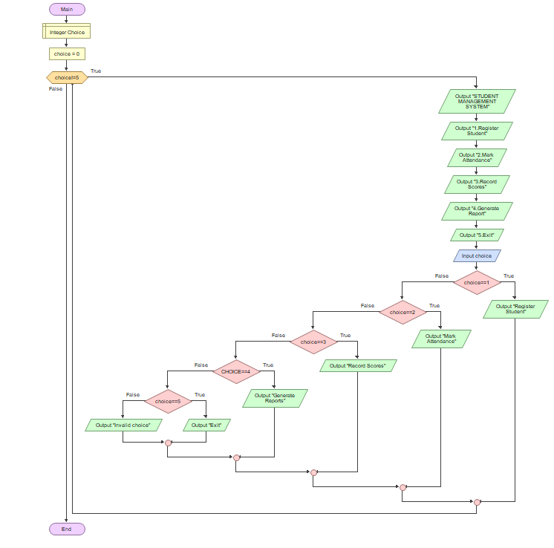
4.2 Report and Risk Check Flow
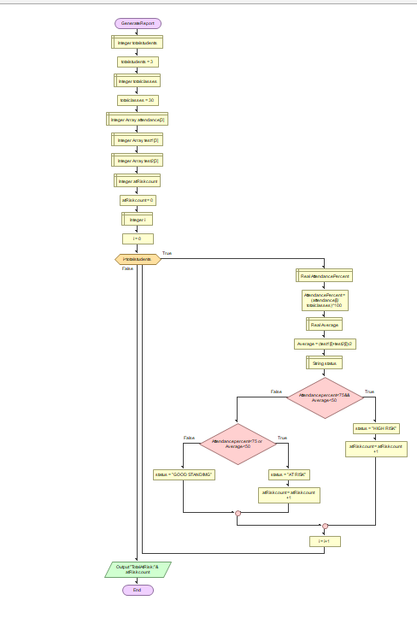

5. Functional Modules
Module / Function | Purpose | Input | Output
Main | Controls the menu and program flow | Menu choice | Calls other modules
Register Student | Adds a new student with validation | ID, name | Confirmation or error
Mark Attendance | Records present or absent for each student | P or A | Updated attendance counts
Record Scores | Records and validates assessment scores | Score (0 to 100) | Updated total score and count
Calculate Attendance | Computes attendance percentage | Days present, total days | Percentage
Calculate Average | Computes average score | Total score, score count | Average
Determine Grade | Converts average to a letter grade | Average | A, B, C, D or F
Check Risk | Applies Boolean logic to find at-risk students | Attendance %, average | Status text
Generate Report | Produces the class summary | Student records | Displayed report
Problem decomposition: the main problem (track attendance and performance) is split into registration, data capture, calculation, decision making and reporting. Each module does one job, which makes the design easier to understand, test and reuse.
6.Expected Outputs
Scenario 1: Good performance. Aminata attended 18 of 20 days and scored 70, 65 and 80.
Attendance: 90.0% Average: 71.7 Grade: B Status: GOOD STANDING
Scenario 2: Low attendance only. Ibrahim attended 14 of 20 days and scored 60, 62 and 58.
Attendance: 70.0% Average: 60.0 Grade: C Status: AT RISK
Scenario 3: Low attendance and low scores. Mohamed attended 12 of 20 days and scored 40, 45 and 50.
Attendance: 60.0% Average: 45.0 Grade: F Status: HIGH RISK
Scenario 4: Invalid input. A teacher enters a score of 120.
Invalid score. Enter 0 to 100
Class summary: Students needing attention: 2 (from the three students above).

7. GitHub Evidence
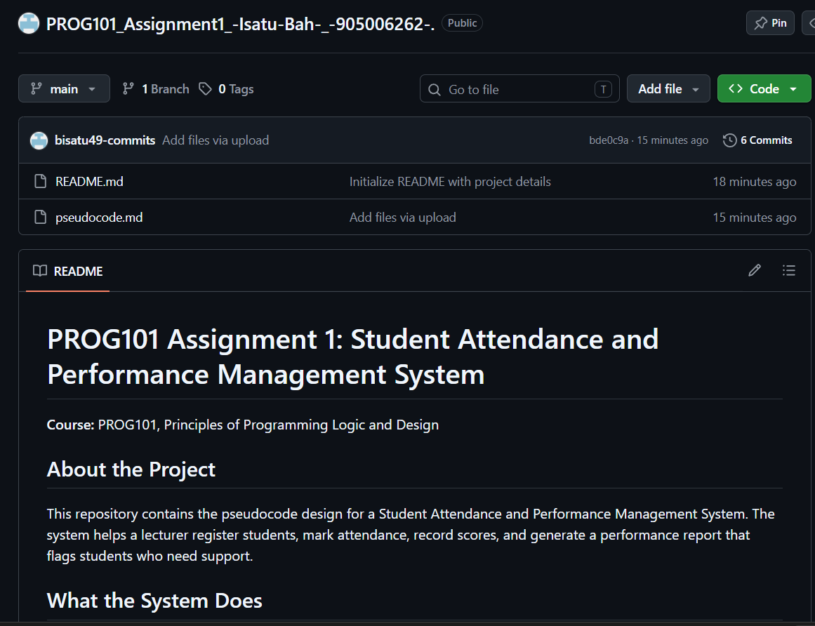

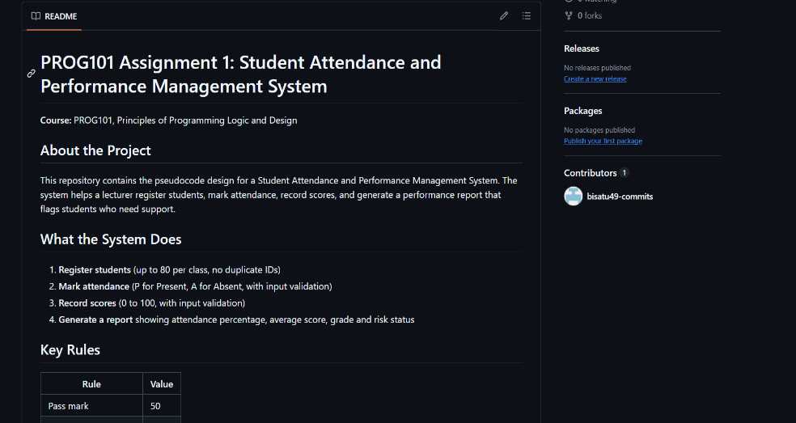
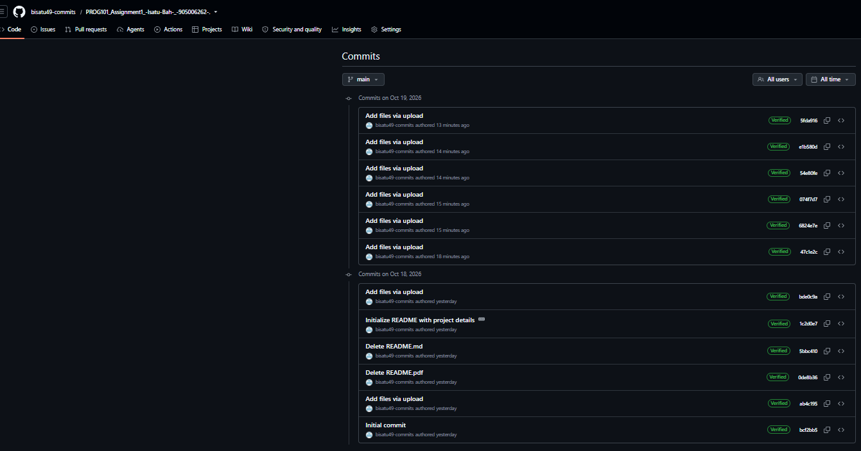
https://github.com/bisatu49-commits/PROG101_Assignment1_-Isatu-Bah-_-905006262-

8. References
United Nations. Sustainable Development Goals (SDG 4, SDG 10, SDG 17). https://sdgs.un.org/goals
Digital Public Goods Alliance. The Digital Public Goods Standard. https://digitalpublicgoods.net
Open Source Initiative. The Open Source Definition. https://opensource.org
Government of Sierra Leone, Ministry of Basic and Senior Secondary Education. Free Quality School Education programme documents.
DHIS2. An example of an open source Digital Public Good. https://dhis2.org

